FAQS FOR SENIORS ON PLASTIC BAG & POLYSTRENE FOAM FOOD SERVICE PRODUCTS BAN

- Does this law apply to senior centers, assisted living facilities, senior daycare, Meals on Wheels, and in general, any and all programs related to senior citizens?
YES – The Ban on Single-Use Carryout Bags, Ban on Polystyrene Foam Food Service Products, and Plastic Straws By-Request-Only (P.L. 2020, c. 117) law includes food service businesses – which applies to all businesses or institutions including government entities that sell or provides food for consumption on or off premises. The ban on single-use plastic carryout bags includes food service businesses meaning all senior facilities and organizations involved in meal service are impacted.
“Carryout bag” means a bag that is provided by a store or food service business to a customer for the purpose of transporting groceries, prepared foods, or retail goods.
“Food service business” means a business that sells or provides food for consumption on or off the premises, and includes, but is not limited to, any restaurant, café, delicatessen, coffee shop, convenience store, grocery store, vending truck or cart, food truck, movie theater, or business or institutional cafeteria, including those operated by or on behalf of any governmental entity.

- Our senior facilities use Styrofoam coffee cups and Styrofoam plates to serve the food to seniors. Will these still be allowed?

NO – The law bans the sale and use of all polystyrene (Styrofoam) food service products which includes Styrofoam coffee cups and Styrofoam plates.

- Our senior facilities use plastic bags to allow the seniors to carry home food from the centers. Will these still be allowed?
NO – The law bans the use of plastic single-use carry-out bags at all food service businesses.

But there are exemptions: “Carryout bag” shall not include: (1) a bag used solely to contain or wrap uncooked meat, fish, or poultry; (2) a bag used solely to package loose items such as fruits, vegetables, nuts, coffee, grains, baked goods, candy, greeting cards, flowers, or small hardware items; (3) a bag used solely to contain live animals, such as fish or insects sold in a pet store; (4) a bag used solely to contain food sliced or prepared to order, including soup or hot food; (5) a laundry, dry cleaning, or garment bag; (6) a bag provided by a pharmacy to carry prescription drugs; (7) a newspaper bag; and (8) any similar bag, as determined by the department pursuant to rule, regulation, or guidance.

- Can seniors bring their own plastic bags to the grocery store to package their own groceries?
YES – The ban on single use plastic carryout bags does not apply to the customer. While all grocery stores over 2500 square feet will not be permitted to provide customers with paper or plastic bag, the consumes can use whatever he/she wishes to pack their groceries. Whether it be plastic bags, paper bags or boxes that they bring to the store to use.
- Can seniors still buy plastic garbage bags, paper bags and zip lock bags at the stores? And any Styrofoam food service product?
YES – plastic garbage bags, paper bags and zip lock bags will still be available for everyone to purchase at retail stores.
NO – Styrofoam food service products will no longer be sold at any retail store in the state.
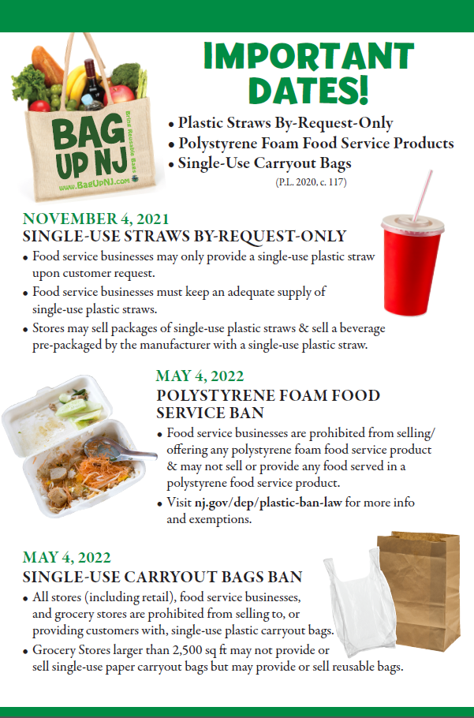

For more information on the NJ Bag Ban Law,

please visit: https://www.nj.gov/dep/get-past-plastic/

For information on Business Compliance, contact the New Jersey Business Action Center
https://business.nj.gov/bags/plastic-ban-law

